Power and Water Corporation

Asim GITHuB DOWNLOAD GUIDE

A power station simulator

Prepared for Power Water Corporation

By Radical Systems Pty Ltd

# Browse to GitHub

GitHub (<http://www.github.com>) is a hosted source repository that has been chosen to host ASIM source code and releases.

To browse directly to the ASIM repository, open Internet Explorer (or alternative web browser) and browse to the following URL: <https://github.com/thinkOfaNumber/Asim/releases>.

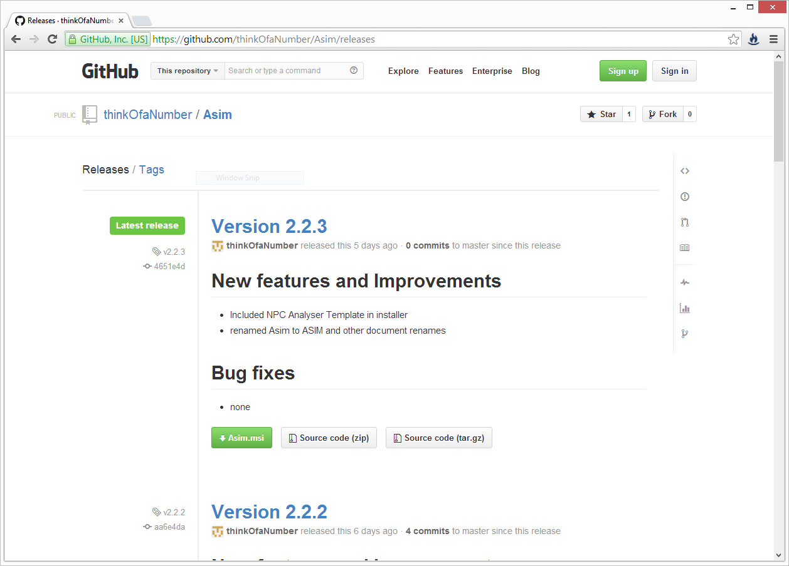

# Browse ASIM releases

You will note that multiple versions of ASIM are available for download. It would be usual to download the latest release unless you have a specific requirement for a prior release. The latest release contains all the latest bug fixes and features.

Each version of ASIM available has a description of the reasons for the new release:

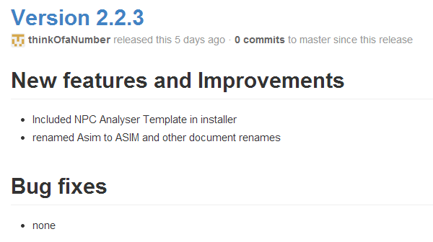

For example, the release shown above has two new features or improvements and no bug fixes since the previous release.

# Download an ASIM release

For each release you will note that there are three packages available to download:



The green highlighted button represents the Microsoft Installer package for ASIM. Clicking on this button will download the installer package to your PC. When you open this package by double clicking it or instructing your browser to open it, ASIM will begin installing (see the Quick Start guide for more information on installing ASIM).

The other two non-highlighted buttons allow you to download a compressed package of source code in two formats: Zip or Tar-GZip. These both contain the same source code files, but are provided in two different formats for convenience – normally you would download a Zip file for a Microsoft Windows PC and a Tar-GZip file for Linux platforms.

If you do not have a specific need for the source code for ASIM, you should download the installer package (green button). The source code packages are for advanced users and require the source code to be compiled into binaries before it can be used.